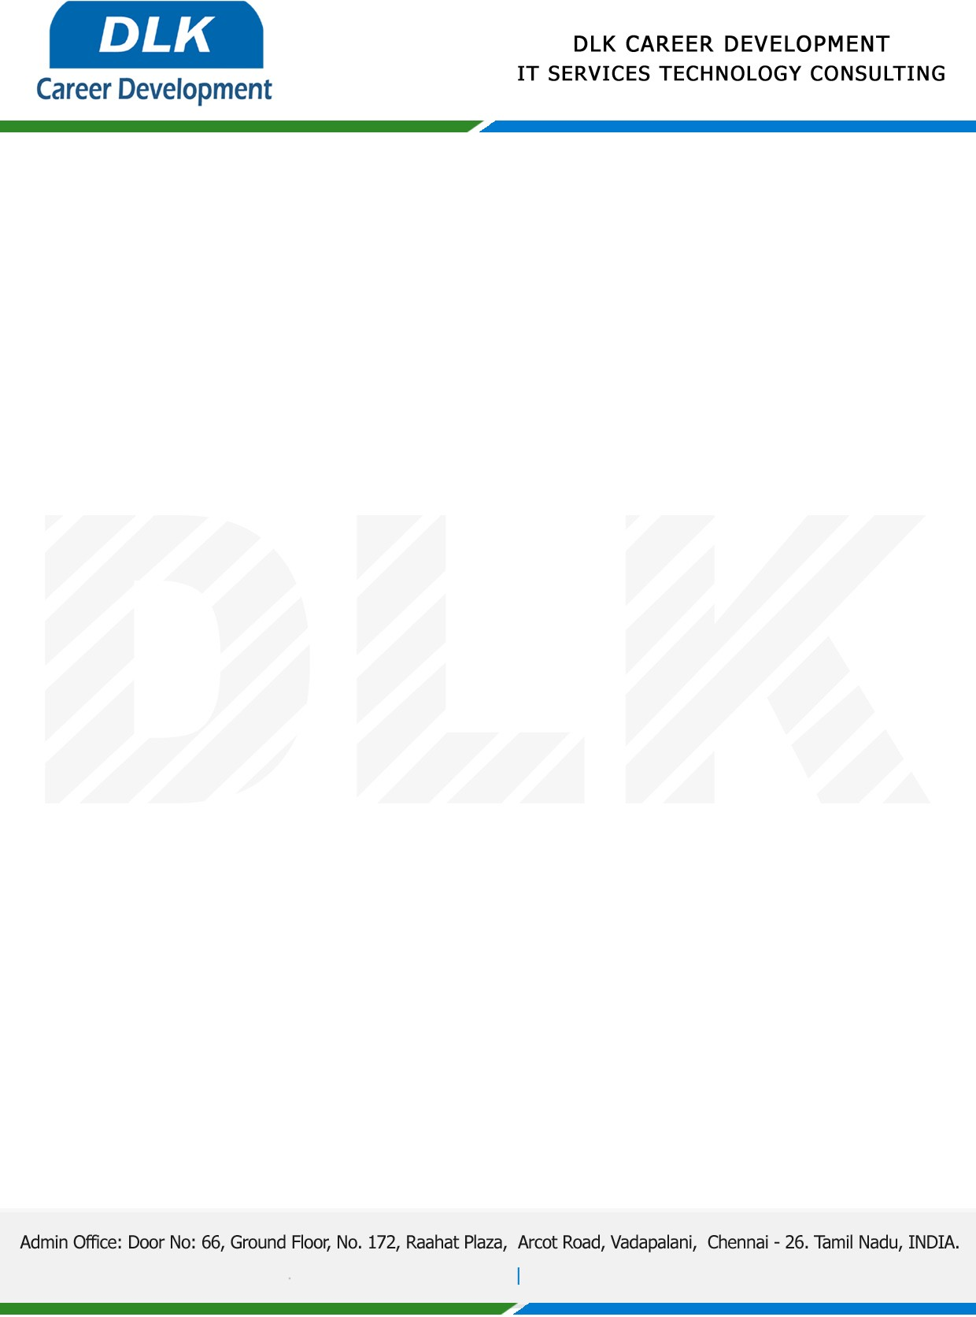

Date: 12/May/ 2023

**SUBJECT: INTERNSHIP COMPLETION CERTIFICATE**

This is to certify that **MR RAM PRAKASH (REG NO: S221978)** of **MCA (COMPUTER APPLICATION)** first year student at **DR.MGR EDUCATIONAL AND RESEARCH INSTITUTE UNIVERSITY, CHENNAI** has Successfully Completed the Internship under the domain of **“Java Programming “**in our organization during the Period **(3rd April 2023 to 5th May 2023).**

We appreciate your interest in **DLK CAREER DEVELOPMENT**

“Best Wishes for Your Future Endeavors “

For **DLK CAREER DEVELOPMENT**

**HR Manager**

**VELMURUGAN J**